**FlyAway**

1. **Home Page :-**

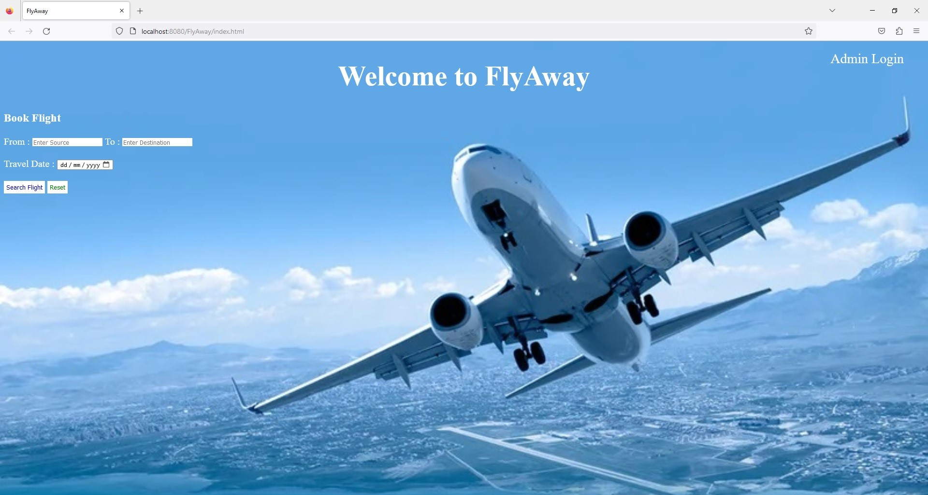

1. **Search Page :-**

On the search page, you have to enter the details like source, destination, and travel date, based on the details it will show you the available flights.

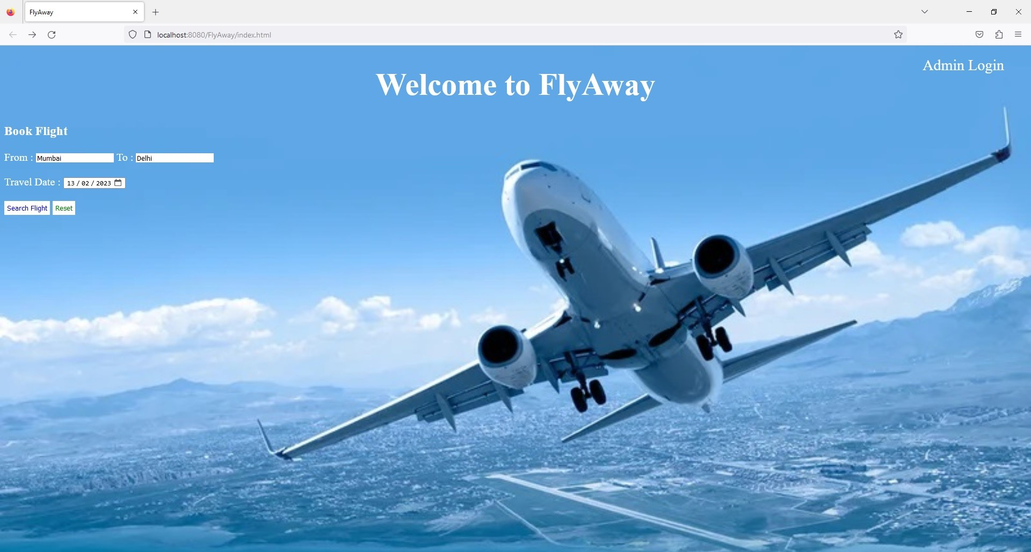

**2.1** Based on the search available flights list will appear

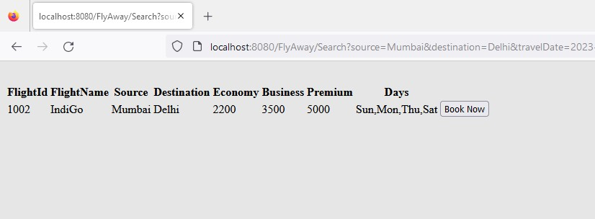

**2.2** Clicking on the book now button will redirect you to the page where you have to confirm the source and destination, enter the class in which you want to travel like the economy, business, or premium, enter the name of the passenger, and number of passengers traveling

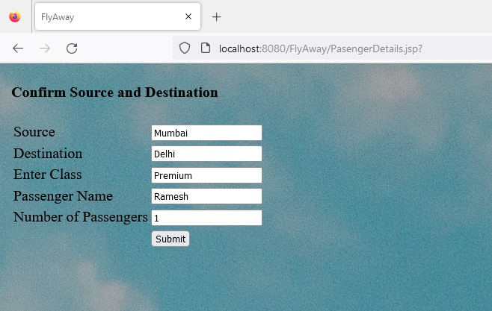

**2.3**  A confirmation page will appear which will show all the above details and the total fare, after clicking on confirm button it will take you to the user registration/login page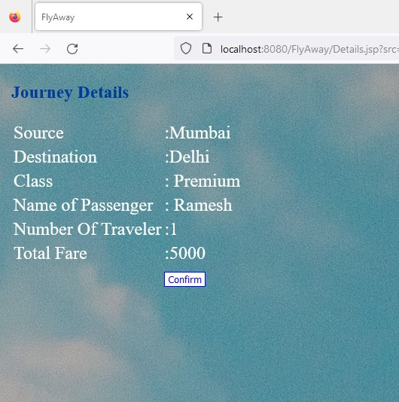

**2.4** If the user is a first-time user, then he has to fill in all the details and register; if the user is an existing user, he has to select the login option.

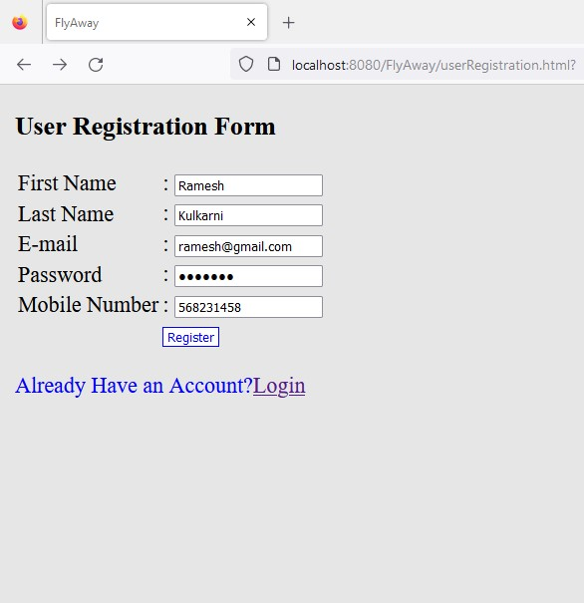

**2.5** After registration user will be redirected to the dummy payment page.

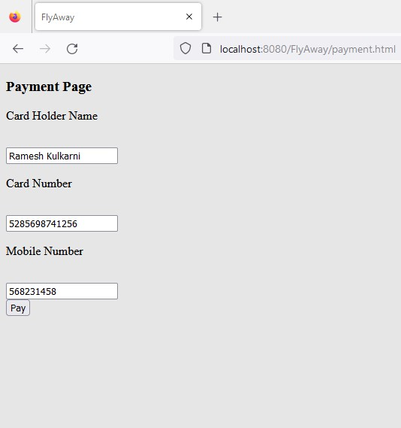

**2.6** Fill in the details and click on pay and a ticket is booked successfully message will appear

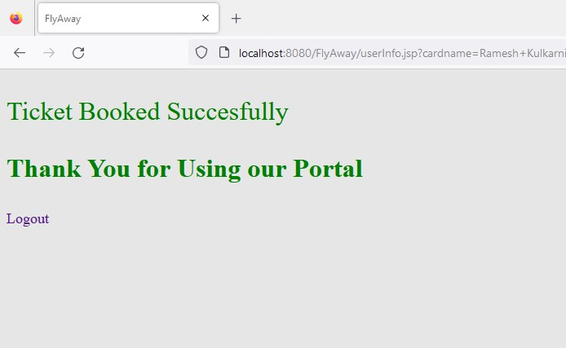

**2.7** If the user selects the option of login, after successful login he will be redirected to the payment page.

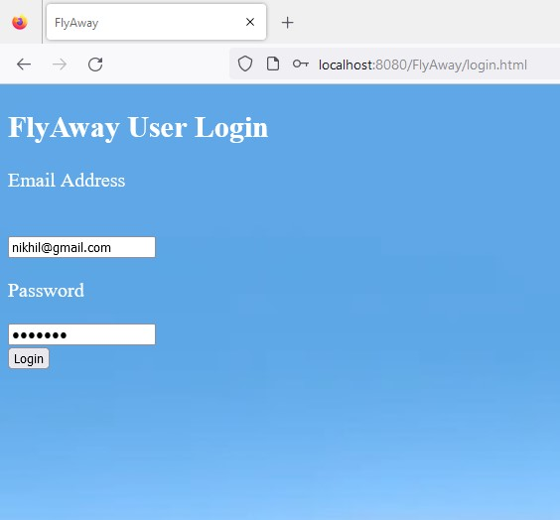

**2.8** After successful login user will be redirected to the payment page and fill in the details on the payment page.



**2.9** Click on pay and ticket booked successfully message will appear



**2.10** If invalid login details are provided, then it will show the message of invalid username or password

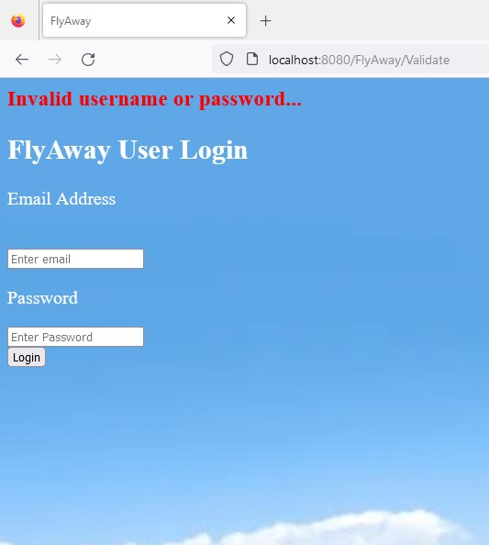

1. **Admin Login :-**

On the home page, you will see the option of admin login.



**3.1** Click on admin login, and enter username and password.

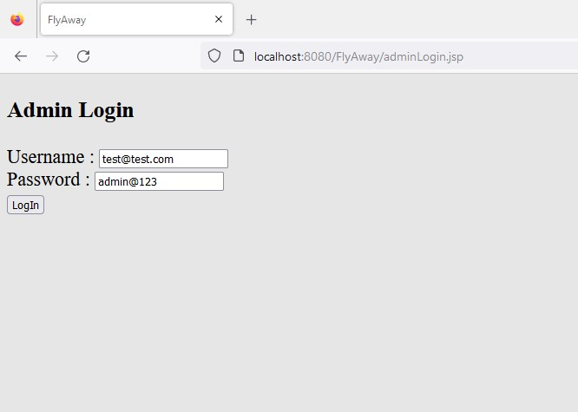

**3.2** After successful login, you will see the admin dashboard.

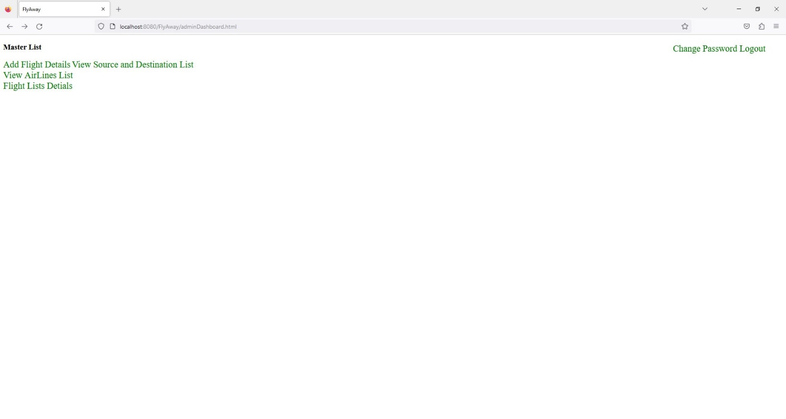

**3.3** Click on add flight, fill in all the details and the flight will get added successfully.

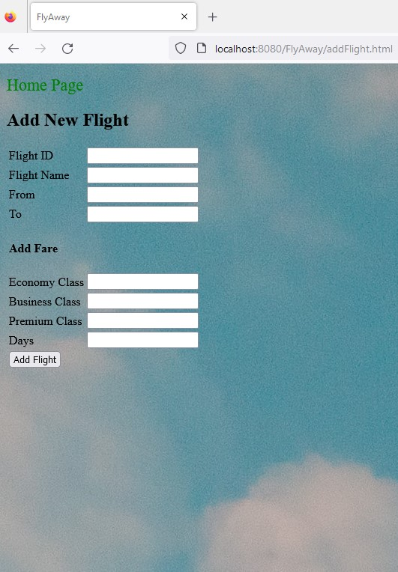

**3.4** View Source and Destination Master List

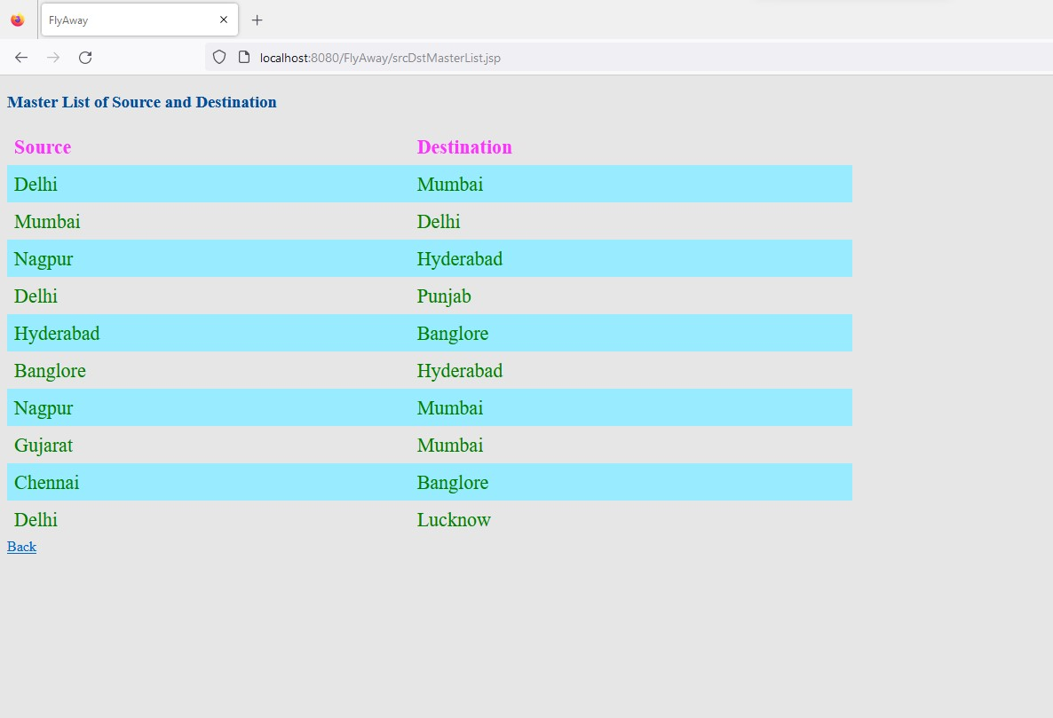

**3.5** View Airline’s List

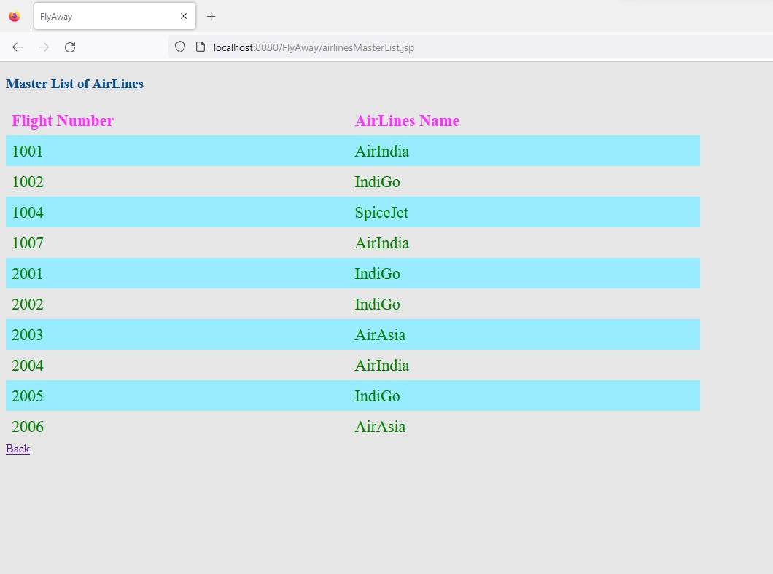

**3.6** Flight Details List

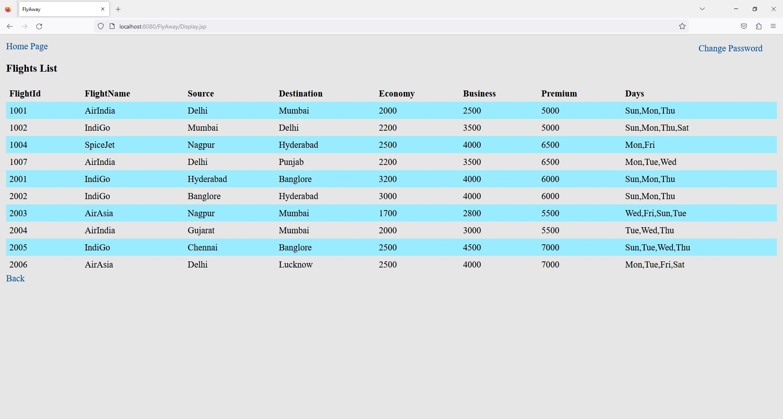

**3.7** Admincan change his password if he wants to.

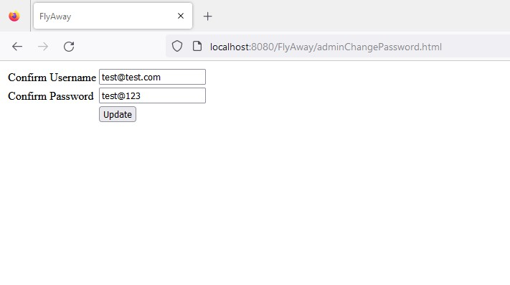

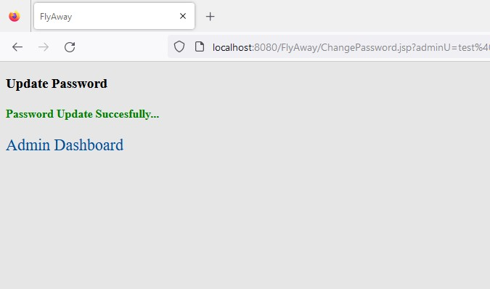

**3.8** There is a logout option for admin.



**GitHub Link :-** https://github.com/nikhilwaware/FlyAway.git